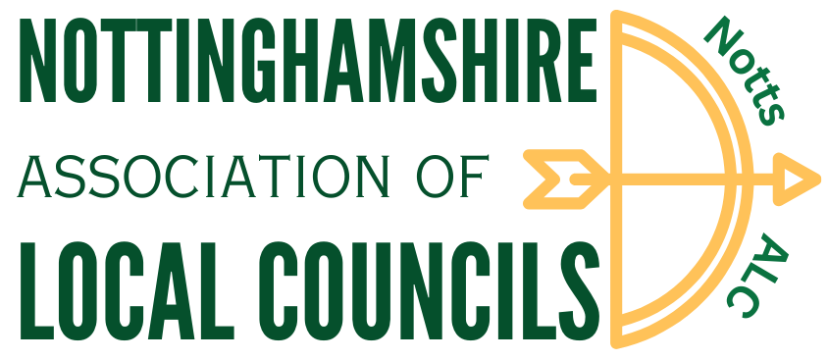

**NOTTINGHAMSHIRE ASSOCIATION OF LOCAL COUNCILS**

**79th ANNUAL GENERAL MEETING**

2pm Saturday 12th October 2024

YMCA, Newark

1. Apologies for absence
2. Welcoming remarks – Cllr Mick Baker (Chair)
3. To approve the Minutes of the 78th Annual General Meeting held on 11th September 2023
4. To receive and adopt the Annual Report for 2023/2024
5. Presentation of the Best Kept Village 2024 Awards
6. Presentation of Long Service Awards
7. To receive and adopt the Accounts for the year ended 31st March 2024
8. To adopt the 2025/2026 subscription recommended by the Executive Committee
9. To appoint the Independent Examiner of Annual Accounts for 2024/2025
10. Election of Officers 2024/2025
    * + 1. Executive Committee
        2. President
11. To approve the adoption of the new Constitution
12. To confirm the offer of free membership of the Association to Parish Meetings

Guest Speaker: Ben Green, External Affairs at the Woodland Trust & South Kesteven District Councillor

**Table Training**

|  |  |  |  |
| --- | --- | --- | --- |
| *3 x 25 minutes* | RCAN | NALC | Woodland Trust |
| 3pm |  |  |  |
| 3.30pm |  |  |  |
| 4pm |  |  |  |